Team Number: 26
Client: David Whitaker
Advisers: Dr. Santosh Pandey
Team Members/Roles:
Team Leader: Chukwudike C-Madu
Team Webmaster: Michael Brumfield
Team Communications Leader: Richard Millan
Team Key Concept Leaders: Daryck Brown & Boris Ndoutoume
Team Email
Team Website: http://may1726.sd.ece.iastate.edu

Revised: 11/19/2016/Version 2

Breast milk monitor
Project plan

Contents
1 Introduction
1.1 Project statement
1.2 purpose
1.3 Goals
2 Deliverables
3 Design
3.1 Previous work/literature
3.2 Proposed System Block diagram
3.3 Assessment of Proposed methods
3.4 Validation
4 Project Requirements/Specifications
4.1 functional
4.2 Non-functional
5 Challenges
6 Timeline
6.1 First Semester
6.2 Second Semester
7 Conclusions
8 References
9 Appendices

1 Introduction

1.1 Project statement
The project is about designing a milk flow meter to help mothers track how much volume of milk they feed their babies. Along with the breast flow meter, we are also building a mobile App in which the data will be sent to real time and display the statistic and volume of milk to the mother.

1.2 purpose
This project is meant to be beneficial to mothers who are not sure how much is being fed to their child. Its purpose is to prevent over or under feeding of infants.

1.3 Goals
Ours goals to complete this project are to design a working and accurate breast flow meter device that would measure milk in real time. The meter must be able to measure milk while NOT hindering the feeding process of the mother and child. Another goal is to build a mobile application that can display and store data that is read from the breast meter real time.

2 Deliverables
Flow meter
Our approach to design and build the flow meter are the following:
- Gathering hardware information from client
- Propose plan to advisor
- Analyse and identify different sensors
- Analyse and identify bluetooth components for the communication
- Analyse and design an assembly plan of the all the parts
- Assemble the device together and start testing
- Test integration with hardware and mobile App

Mobile App

- Gathering software information from client
- Propose plan to advisor
- Context Diagram
- Determine functional requirements
- Develop prototype based on functional requirements
- Determine non functional requirements
- Integration of hardware and mobile App

3 Design
There are two (preferred) solutions for approaching this project. Our first solution is creating a LED sensor ring, that would measure by the interference of milk flowing in between the LED and photodetector. Our second solution is to create an impedance measuring ring. This ring would consist of four plates in which a current will flow through two of these plates and the impedance (resistance and capacitance) would be measured from the other two plates across the current induced plates. When nothing (air) flows through these four plates, the resistance is very high and the capacitance is very low. When a liquid flows through, however, the resistance drops significantly and the capacitance will rise.
Once the data of flow meter is being tracked by the ring then send that data through bluetooth into a mobile application. This data will be manipulated using a software algorithm so that the user can track the exact quantity of milk consumed by the baby real time in millimeter.
.

3.1 Previous work/literature
Vasa technology in Egypt has come up with the idea measuring the flow of breast milk. They idea consist of using a physics phenomena which is a fluid passing over a hot surface cools the surface. The cooling rate is directly related to the fluid flow. They are using a temperature sensor to measure the temperature of the surface and a heat sensor to measure how cool the surface is getting. The collaboration between the two sensors is what actually gives us the flow meter.
Here are some diagram of how they represent it;
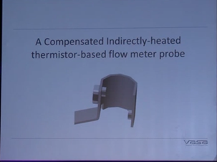
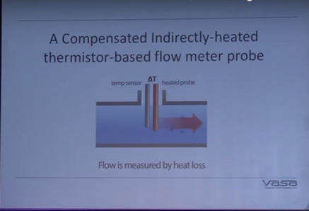
There is also a company, milksense that has a machine that can measure the flow of breastmilk. It is very similar to our project in that it doesn’t hinder the flow of breastmilk and does not come in contact with the baby. The way ours is different is that it integrates with a mobile application and our measurement is instantaneous, while MilkSense’s takes 10 seconds
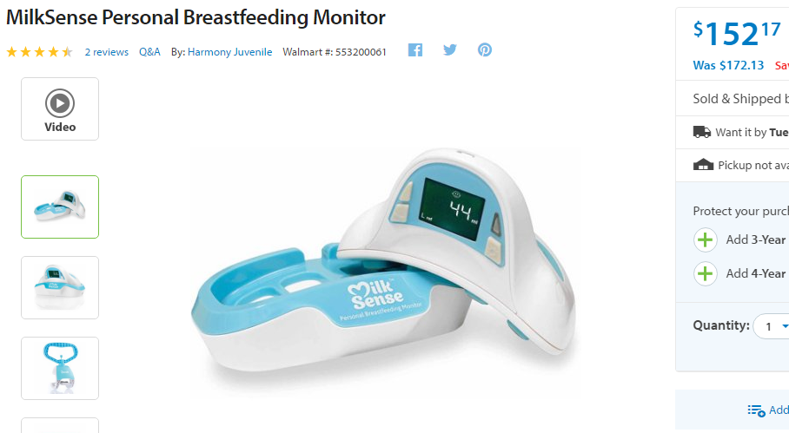
Milk sense breast flow meter

3.2 Proposed System Block diagram
Hardware:
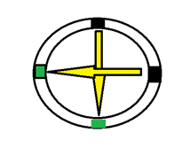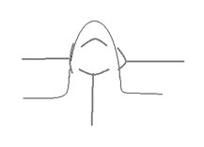
LED Light Intensity Measurement:
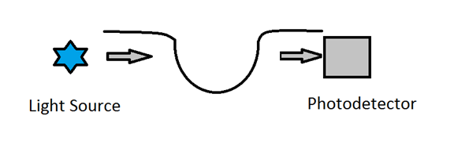
Impedance Measurement:
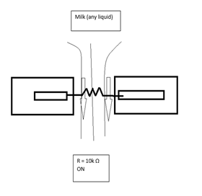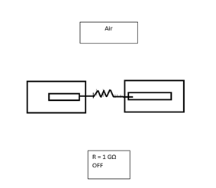
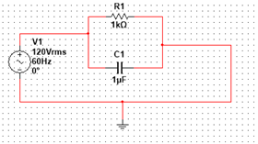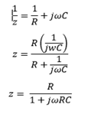
Software:
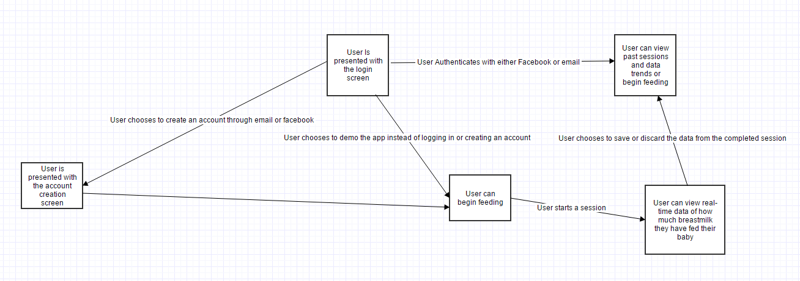

3.3 Assessment of Proposed methods
The two methods we looked at involved using a probe and measuring the change in temperature to determine the amount of flow, and using a series of led sensors. The problem with the temperature approach was that the measurement could be affected easily and there were too many factors that could affect our ability to obtain an accurate measurement. We went with the led approach because our advisor suggested it to us. What we’re going to do is measure the change in the led sensors and find an equation that will give an output that is close to the actual amount of liquid that passed through the sensor. In order to find this equation, we can plot the output from the sensor and the actual output into an excel spreadsheet and have excel make an equation for us. The more data we provide it, the more accurate the equation will be.

3.4 Validation
We will test putting fixed amounts of liquid through the sensor and measure the output that our equation gives us. That will provide concrete evidence if our solution will work or not.

4 Project Requirements/Specifications

4.1 functional
- Working sensor that can communicate over bluetooth
- Mobile Application that can send and receive data over bluetooth
- Mobile Application that can save user data and has user accounts and can authenticate users through Facebook

4.2 Non-functional
- Device can accurately measure flow within a 10% percentage error
- Mobile application runs smoothly and doesn’t have UI that hangs or lags

5 Challenges
Getting the equipment to be able to test the device has proven to be tricky. We just recently got all of the project materials and have now begun testing the device. Another issue we have is that we can’t find a sensor that allows for data to be sent over bluetooth. We are going to have to find a way to send the data from our device to a component that can send and receive bluetooth data. This could prove to be tricky in the future. We also had a slight issue with Facebook integration. Facebook only allows you to register your API key if your app is on the app store or google play store. Since we are still in the development stages, we can’t register the key. So the button to authenticate using Facebook will throw you an error if you try to use it. However, it does not crash the app.

6 Timeline

6.1 First Semester
For the first semester on the software side we aim to have a working mobile application that can receive and send data over bluetooth. We need the application to be able to maintain two-way communication between the device and the phone and be able to save that data. For the hardware part of the project we aim to have a product that can measure data in some way. It doesn’t need to provide the output in ounces, but we want to at least to be able to measure the flow and output it in some format. We can figure out the equation to translate it into ounces in the second semester

6.2 Second Semester

For the second semester we want to be able to accurately measure data within a certain percentage error. We also want the hardware part of the project to be able to communicate with the software side of the project over bluetooth. We need to have the mobile application be fully functional, and it needs to be integrated with Facebook. Once we have the project integrated we will begin focusing on the stretch goals of the application. Which includes generating trend graphs for users. Once all functionalities of the flowmeter and mobile app are fully operational/completed, we will then optimize the comfort and appearance of the device itself .

7 Conclusions
Our goals are:
- Develop a device that can maintain two-way bluetooth communication
- Develop a device that can accurately measure the amount of milk a mother has breast fed in real time
- Develop a mobile application that can interface with this device and display the information that the device is reading

8 References
A lot of references we have used have been taking different ideas and concepts from different classes we have taken at Iowa State University. We had to read some academic research on how flow is measured in the beginning when we had to figure out which flow technique we would use. We later cited some similar breastmilk reading technologies like the “ Milksense” that is sold at Walmart. We will be using a lot of open discussion forums to see if people have had similar ideas with the LED sensors. A lot of white sheets from hardware purchased from electric component sites will be implemented throughout this project. We will just find ways to manipulate the hardware to fit our needs. Our advisor has a lot of knowledge in bio-engineering related projects so he will be our main resource for our academia needs.
Flow Techniques
- Furness, Richard A. (1989). Fluid flow measurement. Harlow: Longman in association with the Institute of Measurement and Control. p. 21. ISBN 0582031656.
- Miller, Richard W. (1996). Flow Measurement Engineering Handbook (3rd ed.). Mcgraw Hill. p. 6.16-6.18. ISBN 0070423660.
Similar Technologies
- http://milksense.com/template/english/milksense-tech-en.html
- http://www.digikey.com/
- https://www.sparkfun.com/?gclid=CIPb-KWF6s8CFYWCaQod-cgLnA

9 Appendices

Figure(1): Project Timeline
